Executive Summary:

GDP abbreviated for Gross-Domestic-Product sub-indexed to:

* PPI abbreviated for Producer-Price-Index
* CPI abbreviated for Consumer-Price-Index

Tabled as such that Eskom receives focus:

|  |  |  |  |  |  |  |  |  |  |
| --- | --- | --- | --- | --- | --- | --- | --- | --- | --- |
| GDP | PPI |  |  |  |  |  |  |  |  |
| CPI |  |  |  |  |  |  |  |  |  |
| Trial |  |  |  |  |  |  |  |  |  |
| Bal.S |  |  |  |  |  |  |  |  |  |
| Margin |  |  |  |  |  |  |  |  | Audit |
| -FI |  |  |  |  |  |  |  | P |  |
| -HR |  |  |  |  |  |  |  | P |  |
| -MM |  |  |  |  |  |  |  | P |  |

Macro-Economic, Micro-Economic

|  |  |  |  |  |  |  |  |  |  |
| --- | --- | --- | --- | --- | --- | --- | --- | --- | --- |
|  |  |  |  |  |  |  |  |  |  |
| Bio |  |  |  |  |  |  |  |  |  |
|  |  |  |  |  |  |  |  |  |  |
| Chem |  |  |  |  |  |  |  |  |  |
|  |  |  |  |  |  |  |  |  |  |
| Mech |  |  |  |  |  |  |  |  |  |
|  |  |  |  |  |  |  |  |  |  |
| Elec |  |  |  |  |  |  |  |  |  |
|  |  |  |  |  |  |  |  |  |  |
| Tech |  |  |  |  |  |  |  |  |  |
|  | Group | Type | Id | Category | Status | Interval |  |  | Index |

Tech.

Micro : Differentiating dat from data based, move; Charge-Level

Macro: Indistinguishable byte to reside either as Source-Code or Tabled-Data; Core-Level

Summary:

Eskom.

All services categorized below exchange some sort of data, ignoring any host-type, U[re-connect, integrate]

* Departmental, Flat-File
* Uni-Directional, Bank
* Omni-Directional, Vendor
  + Debit-Note

With the following storage effect,

* Stor-Localized
* Stor-Remote
* Stor-P
  + Terminal, App of choice containing Category
  + CashRegister
  + Cellphone
  + ..

$

&

Class

Generated rather Instantiated see ‘00’

Observe for Both Decide Later on Case Statement

1. Document Class Structure Comp. InterClass, InterApp (Match-Pref)
2. Reference in Relational Possible Object Part of Line/Table (Right-Side)

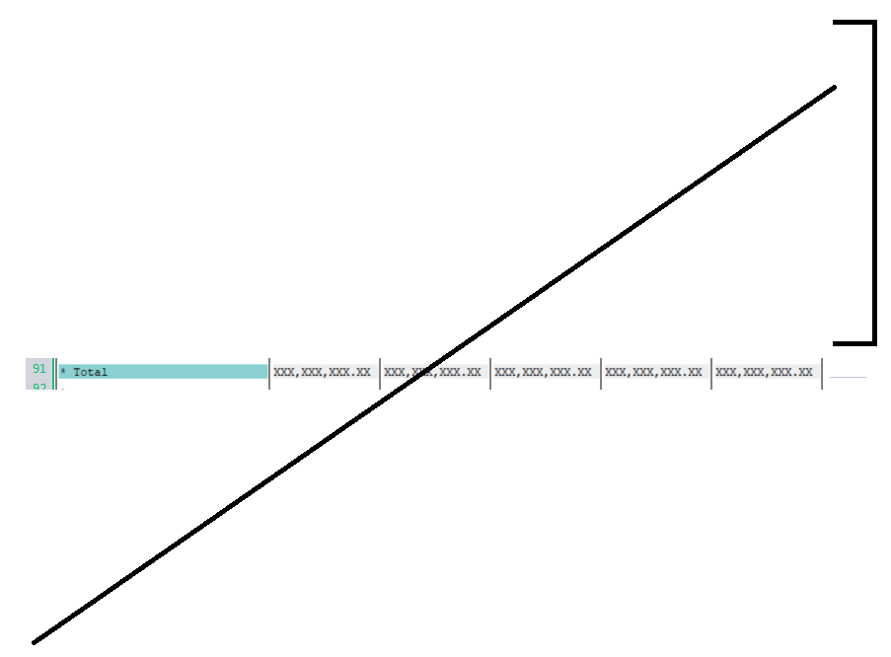

**Note. Re-connected; Integrated; Interfaced**